**PROJECT RISK MANAGEMENT**

The Project Management Body of Knowledge (PMBOK® Guide, 5th Edition) defines project risk as “an uncertain event or condition that, if it occurs, has a positive or negative effect on one or more project objectives, such as scope, schedule, cost, or quality.” Notice that these risks can be considered positive or negative depending on their effects. Project risk management seeks to maximize positive risks while avoiding or mitigating negative risks. A risk management plan is typically included as part of a larger project plan, and is initiated early in the project lifecycle; the risk plan then evolves as the project progresses. It is generally the project manager’s role to maintain the plan and update it periodically to ensure ongoing clarity and effectiveness.

The overall goal of a risk management plan is to manage risk in a way that ensures a successful project outcome. The planning process enables managers to clearly identify risks, and then develop and document risk mitigation strategies and contingency plans. The process also includes identifying both the costs and actions necessary for implementing the plan. Once completed, the plan serves as a guide for everyone involved in a project and is particularly important as a tool to communicate with key stakeholders.

**WAYS TO HANDLE RISK**

Once you’ve identified and evaluated a risk, there are several potential responses. The response you choose will depend on the probability of the risk occurring and the potential severity of its impact on a project.

* **Avoid:** Avoiding risks is ideal, and especially important if the risk is high impact and likely to occur. Avoidance tactics may require greater investment (in order to develop alternative strategies), but this additional cost and effort is appropriate for high-impact, high-probability negative risks.
* **Transfer:**This method refers to transferring risk to another party (for example, the act of purchasing insurance moves the risk to the insurance provider). This response is common for risks that have a high negative impact but a low probability of occurring.
* **Mitigate:** Mitigation aims to reduce either the likelihood or the level of impact of a risk, and is used for risks that are likely to occur, but also likely to be low-impact.
* **Accept:**Acceptance is an option when there is no other solution, but would only be used for low-impact risks that have a low probability of occurring.

Risks can be internal or external, and projects may face a combination of both. Internal risks may include issues with technology, staffing, financial security, and other factors that can be controlled within your organization. External risks can be harder to predict and control, and may include factors such as issues with suppliers, changes in the political climate or economy, or even the weather. The process of analyzing risks and measuring them on a scale of probability and severity can provide the initial framework for determining which of the above methods will be the most effective response to a given risk.

**EXAMPLE OF RISK MANAGEMENT PLAN OUTLINE**

The length and level of detail included in a risk management plan will vary depending on the scope of a project and the needs of an organization. Here is a risk management plan example outline that describes the information you typically include:

* **Introduction:** The first section in a risk management plan may focus on an executive summary or project description, including the purpose of the project. It may go into detail about the scope of the project, objectives, and important background information, and provide an overview of risk management approach and strategies.
* **Risk Management Approach:**This may be a brief summary or detailed section providing information on the risk management process, the methodology used, and specific tools and techniques to be utilized.
* **Roles and Responsibilities:** Here you list the project staff members involved in the risk process, along with each of their roles and responsibilities.
* **Risk Identification:**This section describes how you will identify risks and/or lists risks that you have already found. Methods for risk identification may include brainstorming, examining the project’s [work breakdown structure (WBS)](https://www.smartsheet.com/getting-started-work-breakdown-structures-wbs) in order to identify risks and create a corresponding risk breakdown structure (RBS), conducting expert interviews, consulting with key stakeholders, or reviewing common risks from similar projects.
* **Risk Analysis and Evaluation:** You must analyze risks that you identify to determine what effects they might have on a project, such as a delayed timeline or reduced quality. You must also evaluate these risks for probability and impact. This section may describe how probability of occurrence and impact are calculated and combined to create a numeric score for each risk. Here, you can also define the categories and terms you use to describe the different levels of probability and impact. In addition, if you’ve determined top risks, you can list them here.
* **Risk Response Planning:** You can explain the process for conducting response planning here, including how a project team will develop actions to address both negative and positive risks.
* **Risk Mitigation:** You can list potential risk mitigation strategies here, connecting possible actions to risks based on the level of seriousness. This section may also consider important risks that you have identified, providing detail on what type of mitigation you’ve proposed, ownership for implementing the action, and cost implications.
* **Risk Monitoring and Reporting:**This section may describe how you will monitor risks, the frequency of reviews, how you will identify new risks, and the method and schedule you will use for reporting.
* **Risk Register:** Also called a risk log, the register typically appears at the end of a risk management plan, or as a separate document. The register tracks important details about each risk including probability, impact, overall score, and status. It essentially combines the results from risk analysis and response planning into a spreadsheet or chart for easy reference.

You will need to adjust the content and formatting of this example plan to meet the needs of your business or project. To see how others have handled this process for similar projects, you can search for sample risk management plans online and compare different approaches. Comparing project risk management plan examples may save you time in the long run, especially if you are new to the process. To use the free templates provided below, simply download your chosen file, and make any required edits.

**PROJECT RISK MANAGEMENT PLAN TEMPLATE**

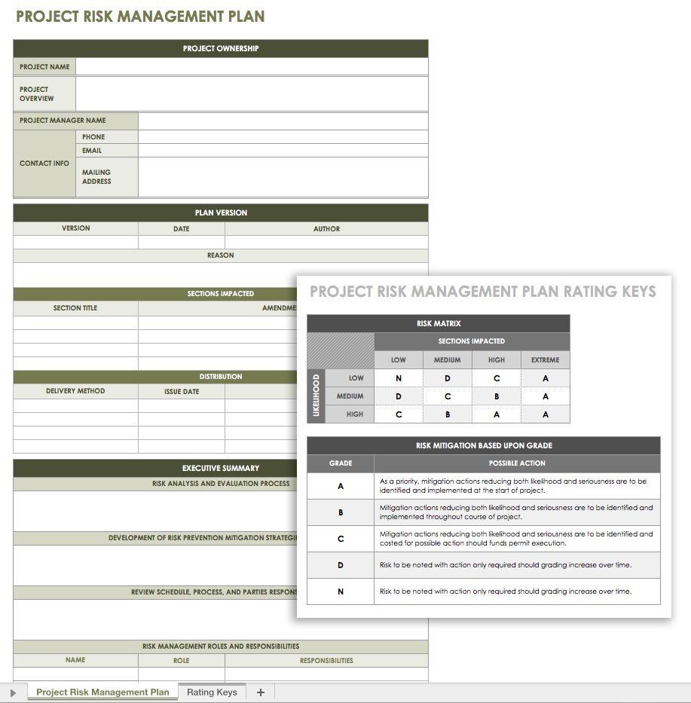

This template allows you to create a project risk management plan for Excel, which may be helpful for adding any numerical data or calculations. You include typical sections in the template, such as risk identification, analysis and monitoring, roles and responsibilities, and a risk register. Add or remove sections to create a customized template for your project

**Risk Severity = Probability X Impact**

The grid below is a model to group and evaluate task and project risk. Risks are represented on a scale of 1 (low) to 25 (high) and are the result of the severity formula.

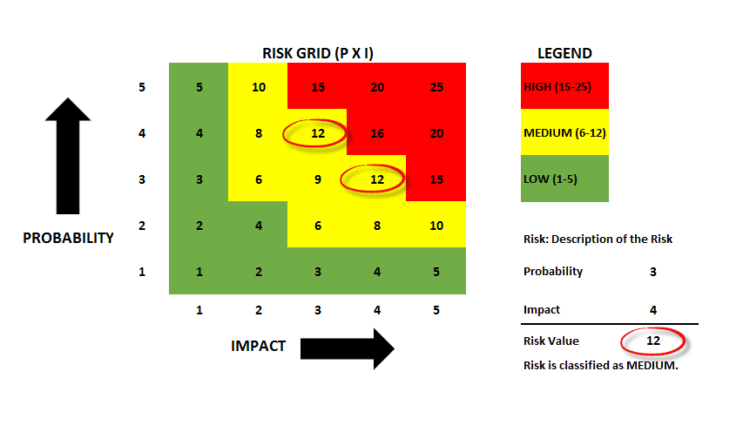

In this simplified model, I arbitrarily identified and grouped risks according to the following rules:

[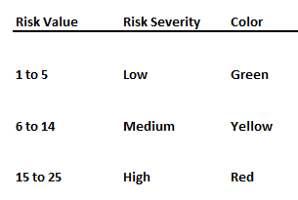](https://46ev833n9u2l3zs8zp44sst3tpr-wpengine.netdna-ssl.com/wp-content/uploads/2014/09/riskassessmentdash_2.png)

Naturally, your organization would need to decide on the value range representing high, medium, and low risk.

The purpose of evaluating the risk is to determine if any action is needed to mitigate or retire the risk. In my model, low risks are only monitored. Medium risks are monitored and a mitigation plan created but not executed. A high risk receives action for retirement.